CHOOSE THE RIGHT OPTION

1-THE FRIDGE IS BETWEEN/UNDER THE DOOR AND THE CUPBOARD.
2-THE DOOR IS NEXT TO/UNDER THE SHELF.
3-THE CLOCK IS IN/ON THE WALL.
4-THE CHAIRS ARE UNDER/ NEXT TO THE TABLE
5-THE TABLE IS UNDER/OPPOSITE THE COOKER.
6-THE POT IS ON/IN THE COOKER.
7-THE BIN IS NEAR/ IN FRONT OF THE DRAWERS.
8-THE MICROWAVE IS NEXT TO /UNDER THE WINDOW
9-THE SINK IS ABOVE/UNDER THE WINDOW.
TRUE OR FALSE

1- THE CHAIR IS NEXT TO THE DESK
2-THE BEDS ARE OPPOSITE THE WINDOWS
3-THE COMPUTER IS UNDER THE DESK
4-THE BOOKCASE IS ON THE WALL.
5-THE BIN IS BETWEEN THE BED AND THE DESK
6-THE LAMP IS ON THE DESK.
7-THE POSTER IS ABOVE THE SHELF
8-THE WINDOWS ARE ABOVE THE BEDS
9-THE CLOCK IS ON THE BED.

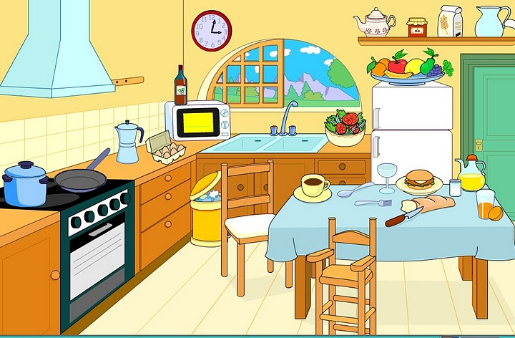
COMPLETE WITH THE RIGHT PREPOSITION

1-THE TOILET IS ………………..THE BATH
2-THE CURTAIN IS………………….THE TOILET AND THE BATH.
3-THE SHELF IS …………….THE WALL
4-THE MIRROR IS …………….THE WASHBASIN
5-THE CUPBOARD IS …………………..THE WASHBASIN
6-THA MAT IS ………………..THE TOILET
7-THE STOOL IS ……………….THE BATH.
8-THE BIN IS ………………..THE CUPBOARD.
9-THE TOWELS ARE ……………..THE CUPBOARD.

MULTIPLE CHOICE

1- THE DOOR IS…………… THE TELEPHONE
UNDER - NEXT TO – OPPOSITE
2-THE T.V IS …………..THE SOFA
NEAR – OPPOSITE – BEHIND
3-THE MAT IS …………….THE TABLE
UNDER – BEHIND – ABOVE
4-THE PICTURE IS ……………THE WINDOW AND THE DOOR.
IN – ON – BETWEEN

